FFIEC IS Booklet Compliance for Log360 Cloud
Automate FFIEC IS Booklet compliance and fortify cybersecurity resilience for financial institutions with Log360.
Region: USA, International | Type: Financial Services, Government/Public Sector, Industry Standard, Incident Management | Category: Compliance | Pricing: Free

Overview
The FFIEC IS Booklet compliance extension in Log360 helps organizations meet the FFIEC Information Security Booklet, the IT examination guidance from the Federal Financial Institutions Examination Council for US financial institutions by providing centralized log management, threat monitoring, and audit reporting. The platform supports FFIEC IS Booklet requirements for risk identification, policy enforcement, access control, network security, malware protection, change management, log management, threat monitoring, incident response, and assurance testing across cloud and on-premise environments.
For II.A — Information Security Risk Identification, Log360 monitors threat indicators, network attacks, and system anomalies to support ongoing risk identification for financial institution security programs. To address II.B — Risk Measurement and Assessment, the platform provides security event metrics, trend analysis, and risk indicator dashboards to support quantitative risk measurement and assessment processes. The extension also supports II.C.1 — Security Policy and Standards Enforcement by providing capabilities that monitors policy configuration changes, GPO enforcement, and security settings to verify security policy implementation and detect policy deviations.

Key Features
- II.C.5 — Asset Inventory and Classification: Log360 monitors AD computer objects, user accounts, and network devices to maintain visibility into the asset landscape of financial institutions.
- II.C.7 — User Access Control Program: Log360 monitors AD group membership, role assignments, and privileged access events to verify access control program compliance.
- II.C.15 — Logical Access and Authentication: Log360 monitors authentication events across AD, Windows, Unix, and cloud platforms to verify logical access controls and MFA enforcement.
- II.C.9 — Network Security Controls: Log360 monitors firewall activity, network device security, intrusion detection events, and traffic patterns to verify network security control implementation.


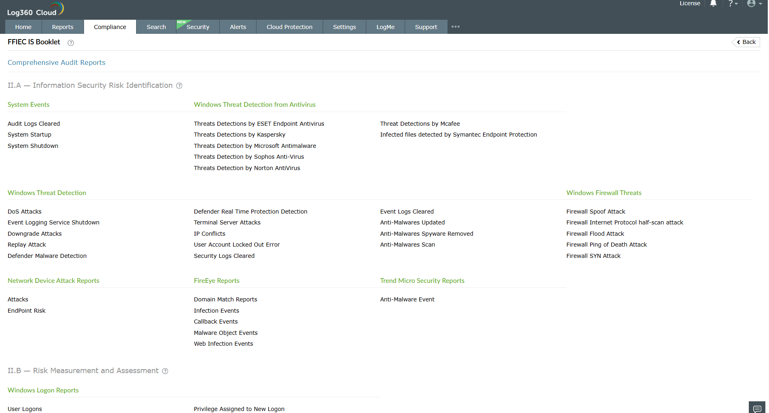
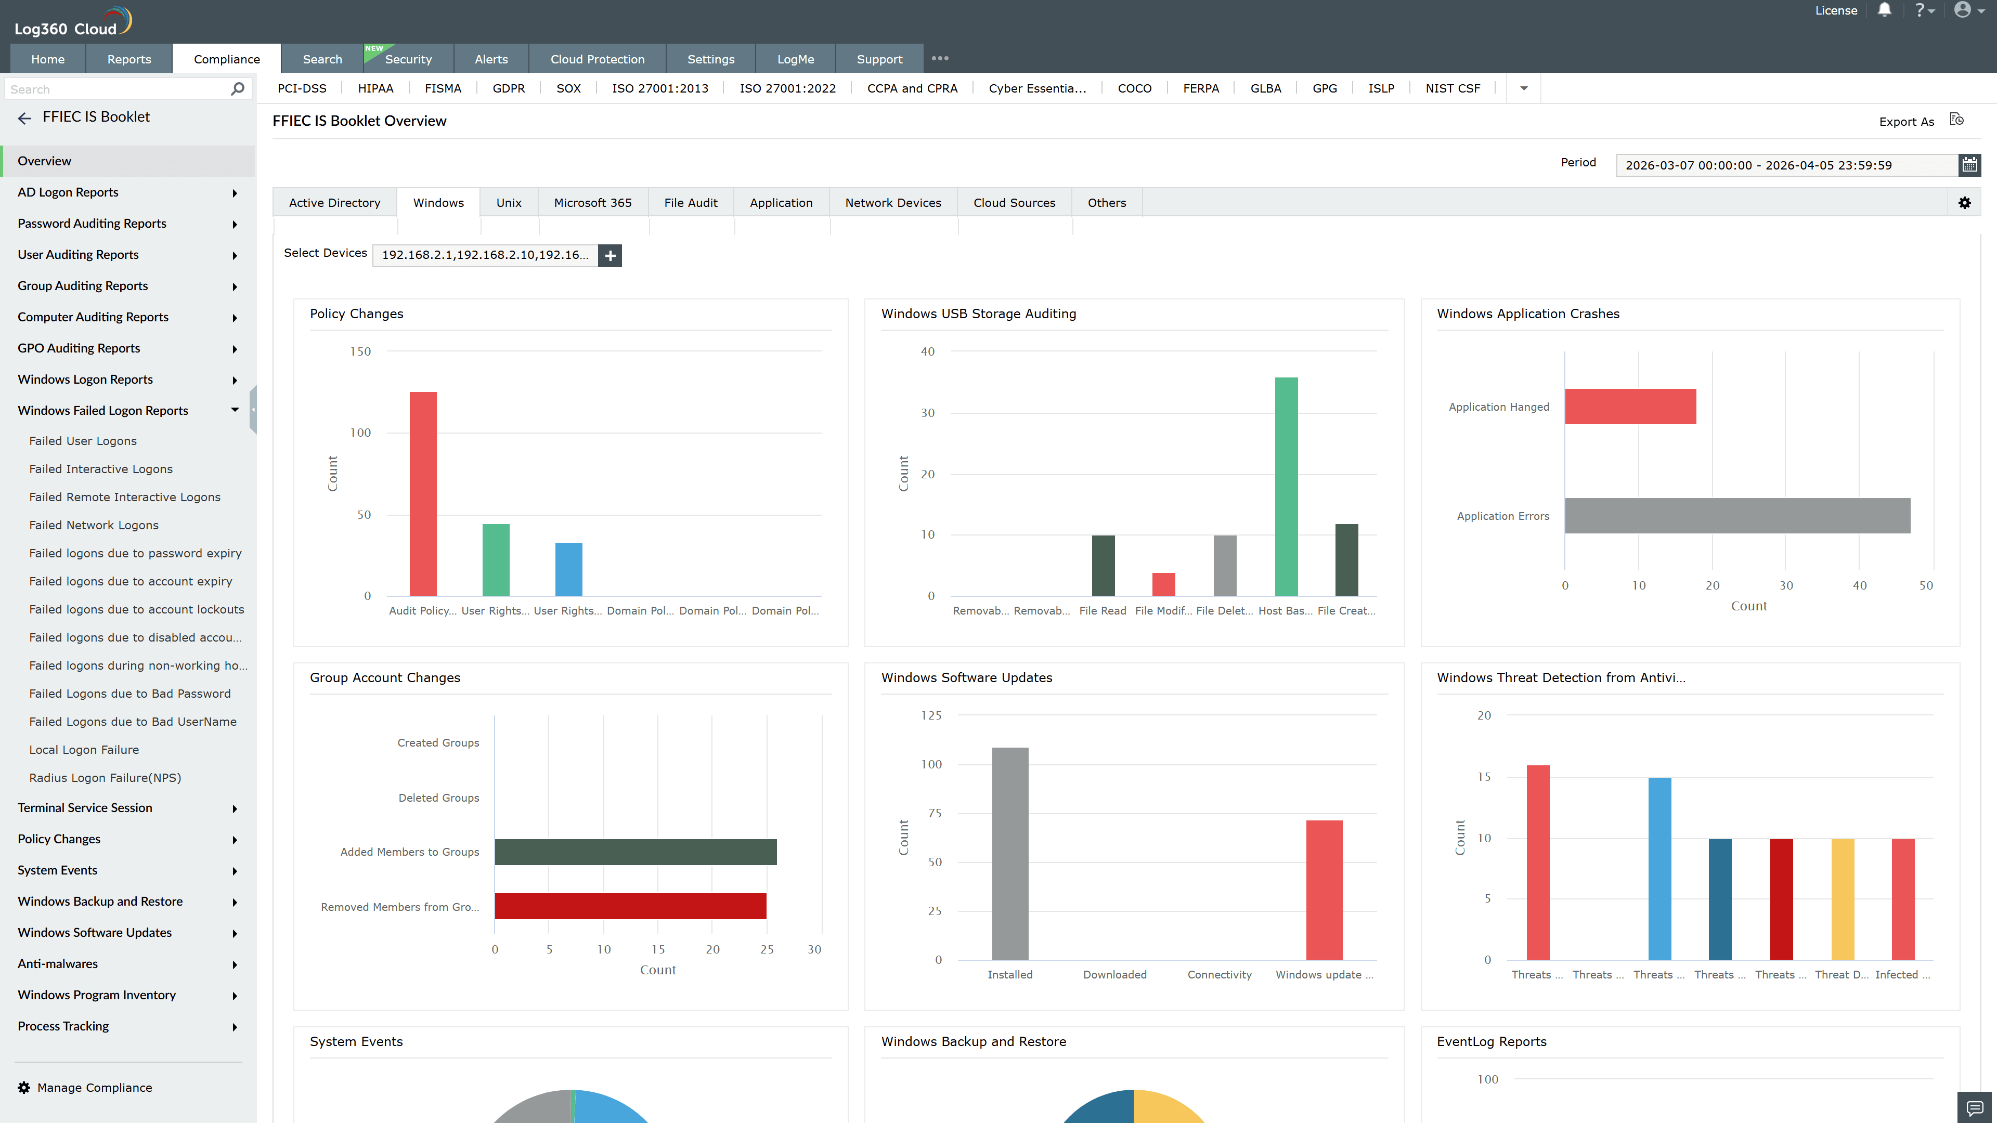
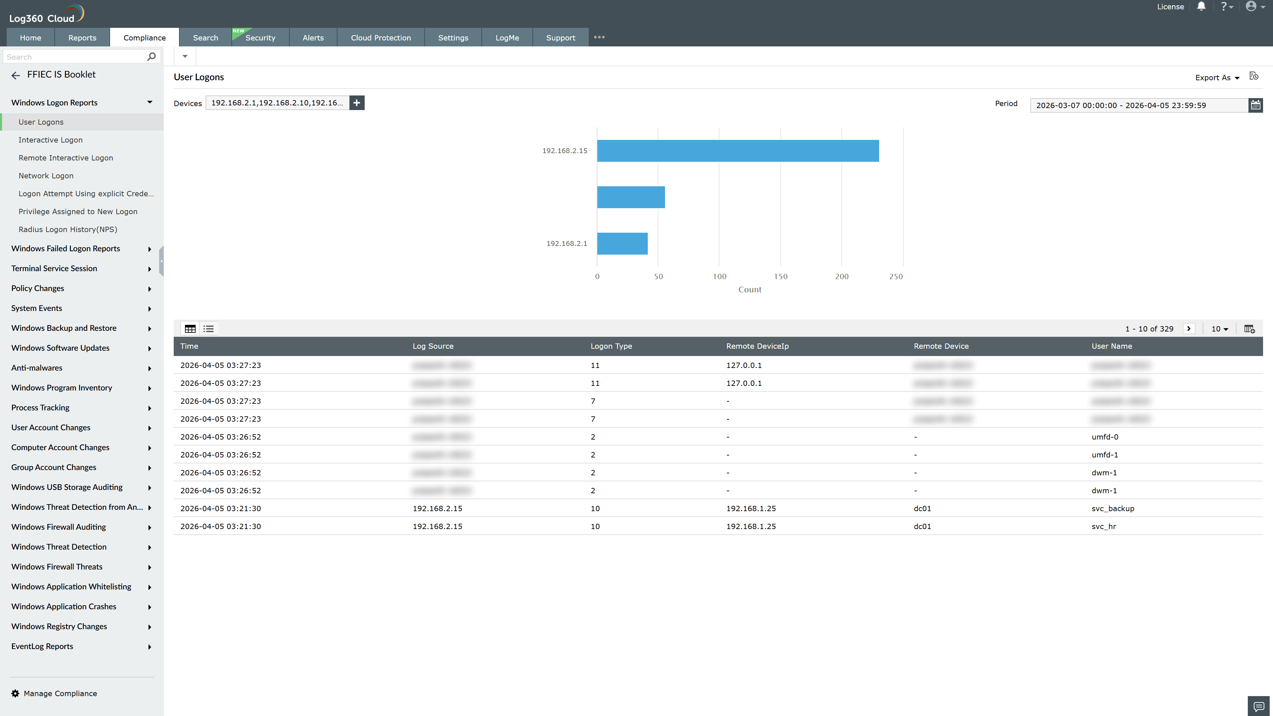
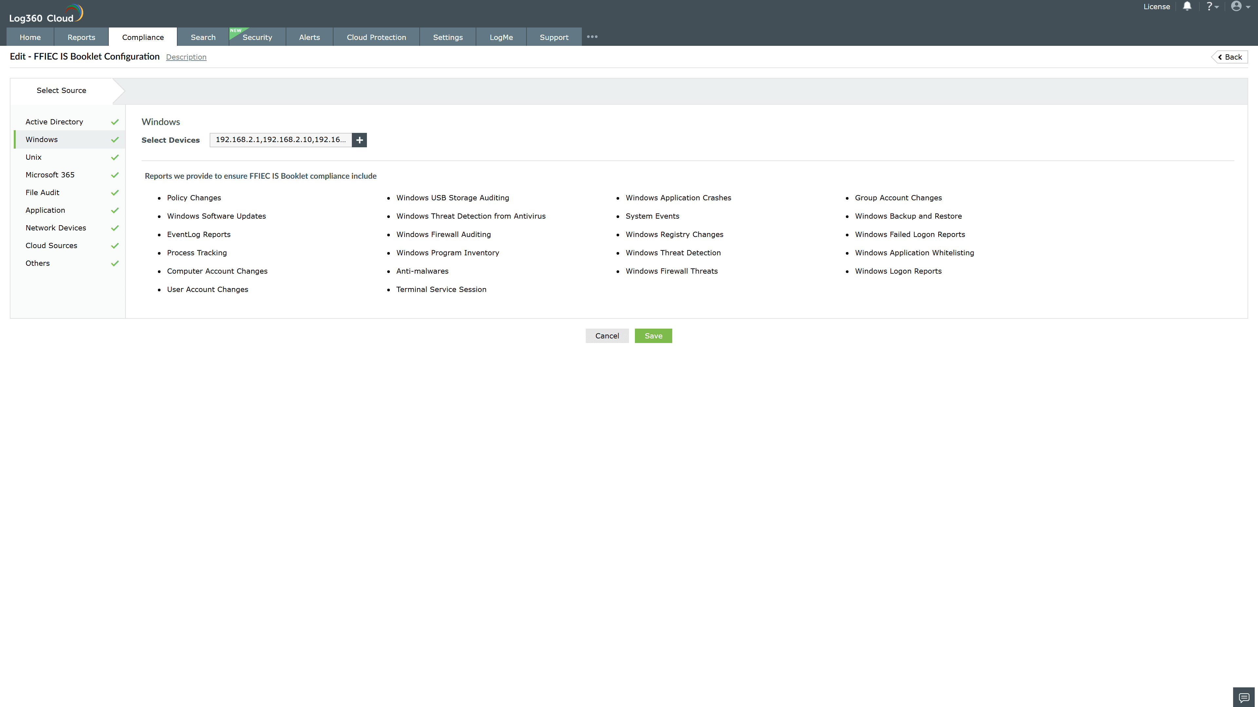
Valid Submission : Yes
Supported Editions : Free, Basic, Standard, Professional, MSSP
Help Document : https://www.manageengine.com/log-management/help/integrations/compliance-extensions.html
Help Video : Not provided
Tags : Log360, Compliance, Privacy monitoring, Data privacy, Regulatory compliance
Supported DCs : US, IN, JP, CA, AU, UK and EU
Privacy Policy:
Terms of Service:
Release Notes:
Predefined reports for the FFIEC IS Booklet.

